**CSE3506 Essentials of Data Analytics**

Name : **Sparsh Raj**

Reg. No. : **19BPS1028**

Lab Exercise: 9: Gradient Descent Optimization

**Objective:** To perform Gradient Descent Optimization

**Question:**

## Gradient Descent - Optimization

rm(list=ls())

# Create a sequence of elements in a Vector to generate sequences when plotting the axes of figures or simulating data.

xs <- seq(0,4,len=20)

xs

## [1] 0.0000000 0.2105263 0.4210526 0.6315789 0.8421053 1.0526316 1.2631579

## [8] 1.4736842 1.6842105 1.8947368 2.1052632 2.3157895 2.5263158 2.7368421

## [15] 2.9473684 3.1578947 3.3684211 3.5789474 3.7894737 4.0000000

# Define the function we want to optimize

f <- function(x) {1.2 * (x-2)^2 + 3.2}

# Plot the function

plot(xs , f (xs), type="l",xlab="x",ylab=expression(1.2(x-2)^2 +3.2))

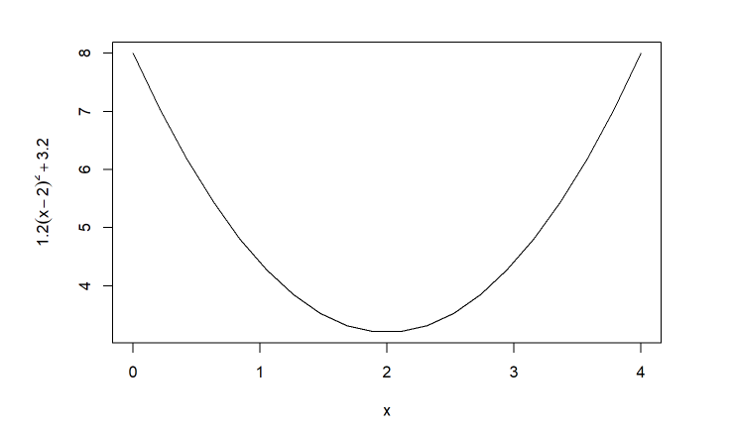

# calculate the gradient df/dx

grad <- function(x){

1.2*2*(x-2)

}

# df/dx = 2.4(x-2), if x = 2 then 2.4(2-2) = 0

# The actual solution we will approximate with gradient descent

# is x = 2 as depicted in the plot below

#lines (c (2,2), c (3,8), col=“red”,lty=2) #text (2.1,7, “Closedform solution”,col=“red”,pos=4)

# gradient descent implementation

x <- 0.1 # initialize the first guess for x-value

xtrace <- x # store x -values for graphing purposes (initial)

ftrace <- f(x) # store y-values (function evaluated at x) for graphing purposes (initial)

stepFactor <- 0.01 # learning rate 'alpha'

for (step in 1:5000) {

x <- x - stepFactor*grad(x) # gradient descent update

xtrace <- c(xtrace,x) # update for graph

ftrace <- c(ftrace,f(x)) # update for graph

}

plot(xs , f (xs), type="l",xlab="x",ylab=expression(1.2(x-2)^2 +3.2))

lines ( xtrace , ftrace , type="b",col="blue") # type=b (both points & lines)

text (0.5,6, "Gradient Descent",col="red",pos= 4)

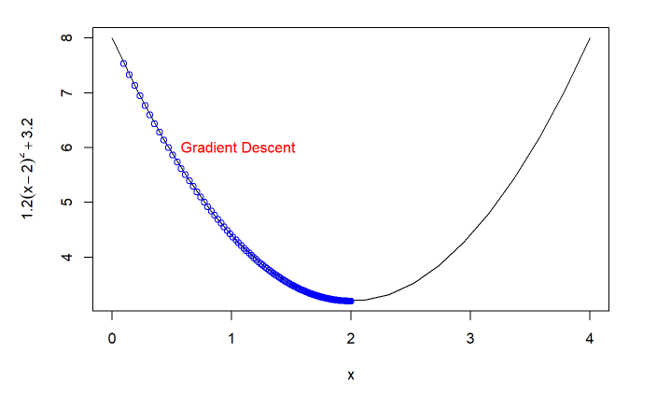

# print final value of x

print(x) # x converges to 2.0

## [1] 2

plot(xs , f (xs), type="l",xlab="x",ylab=expression(1.2(x-2)^2 +3.2))

text(2,4,"x=2",col="red",pos=1)

text(2,4,"(Global minimum)",col="red",pos=3)

